Bitwise operator
1. &
2. or (|)
3. ~ (not)
4. >> (right shift)
5. << (left shift)
6. ^ ( xor)
ASCII TABLE

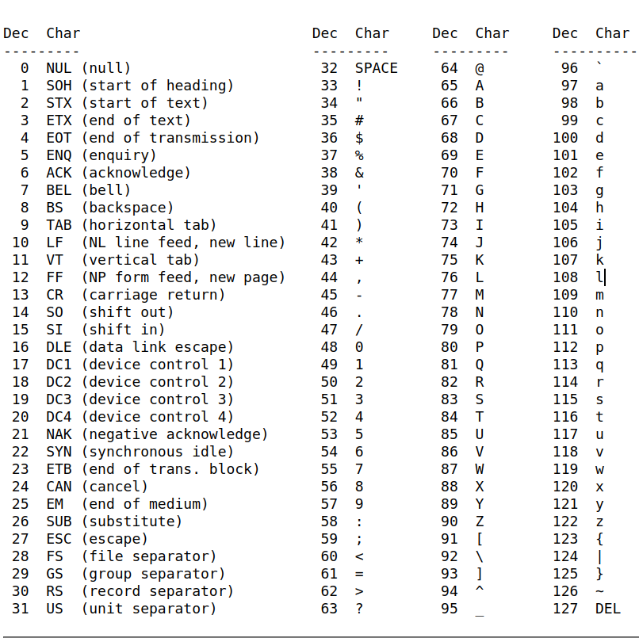
01010011
10100110
01001100
10011000
24+128 = 152
Identity Operators
1. is (===)
strictly ecual (same datatype and same value)
2. is not (reciprocal)

Membership Operator

in ( True if value is found in secuence )

eg print(“hello India How are you”)
print(“he” in a)
returns true

